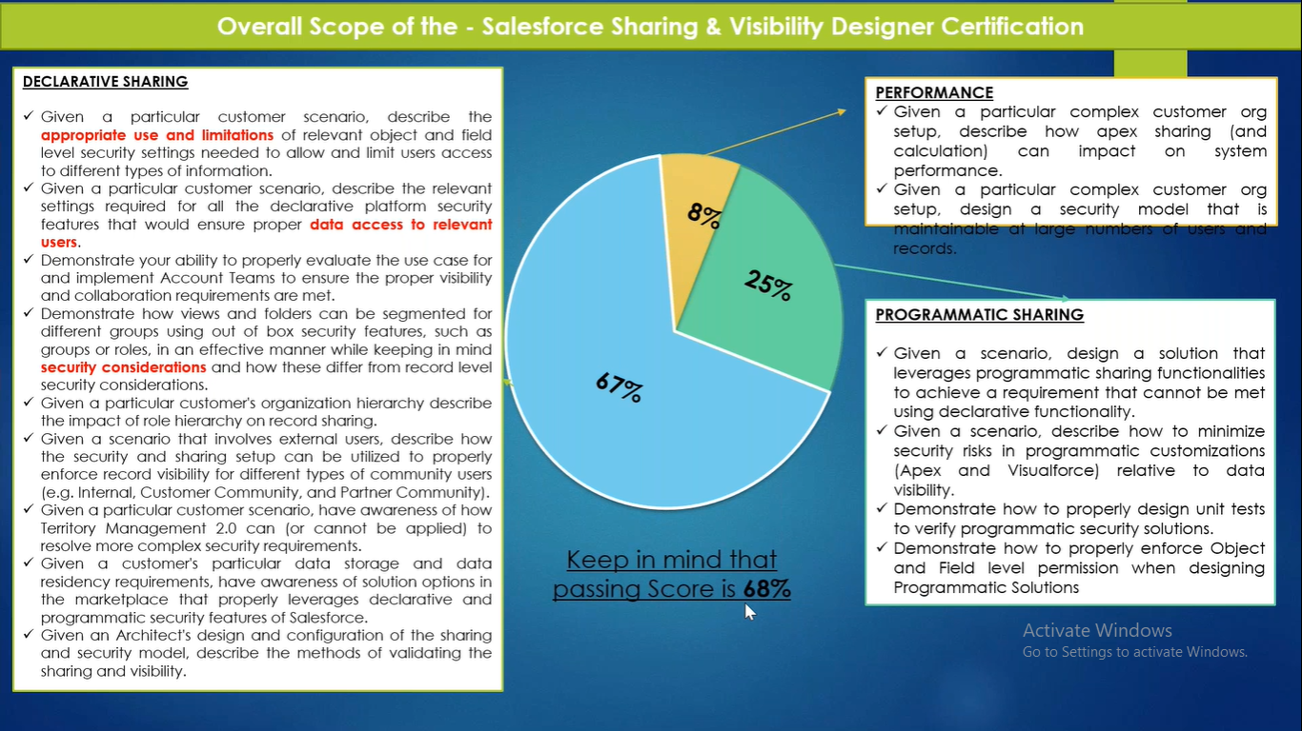

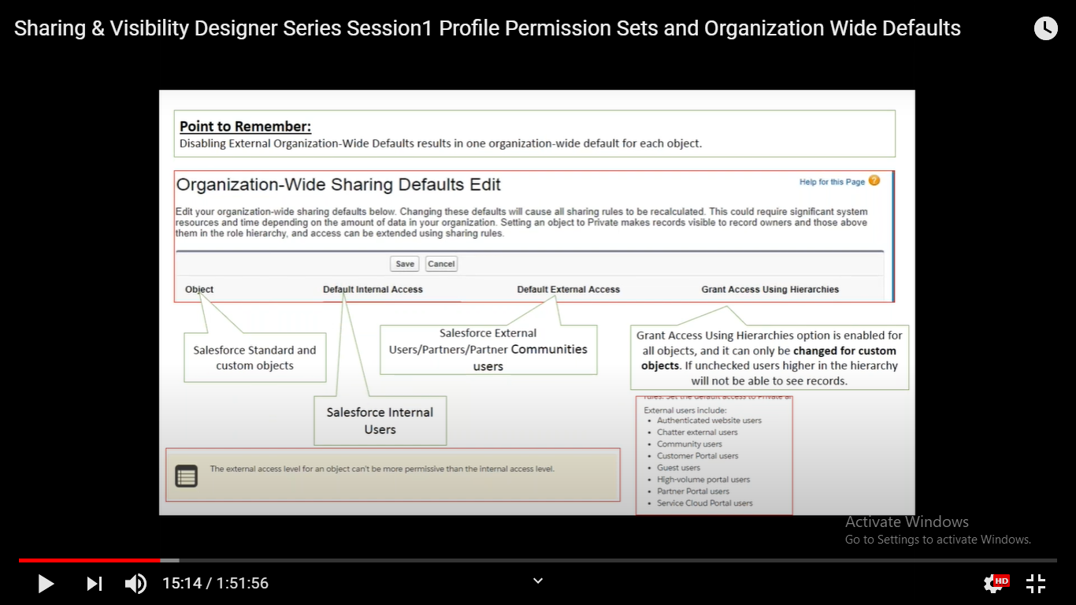

About External Access:

1. The external access level for an object can’t be more permissive than the internal access level. Below screenshot will help us to understand this statement.
2. Before you set the external organization-wide defaults, make sure that they are enabled. From Setup, enter Sharing Settings in the Quick Find box, then select **Sharing Settings**, and click the **Enable External Sharing Model** button. External organization-wide defaults are automatically enabled in all orgs created in Spring ’20 or after and in all orgs with communities or portals.

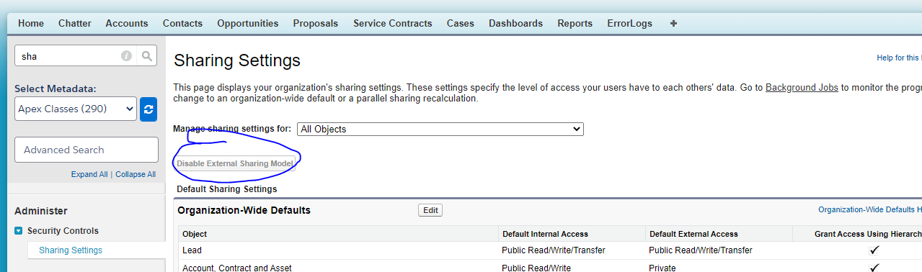

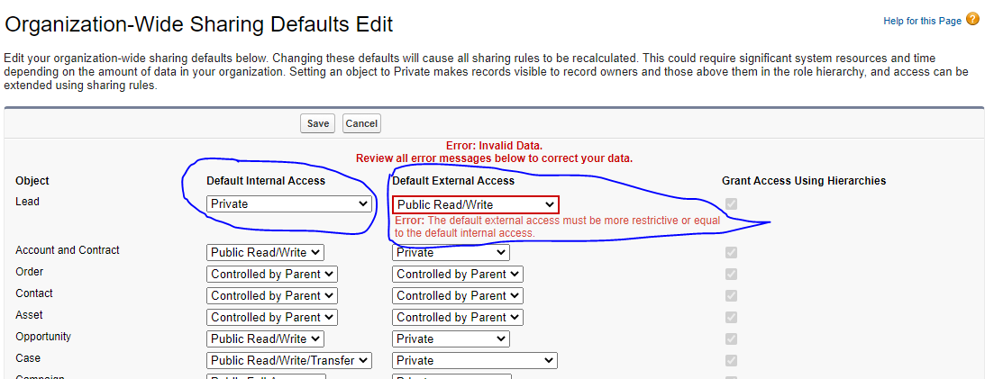

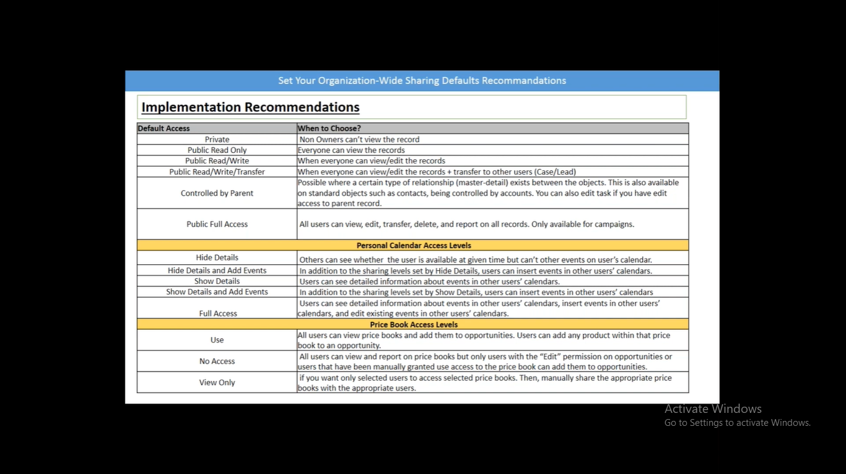

<https://help.salesforce.com/articleView?id=sharing_model_fields.htm&type=5>

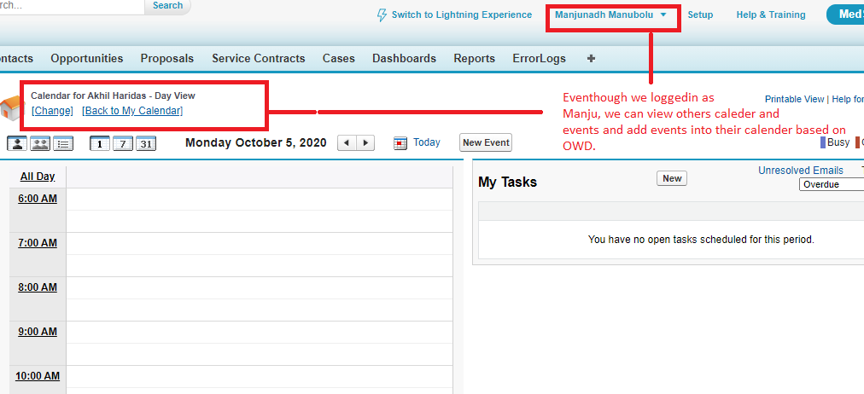

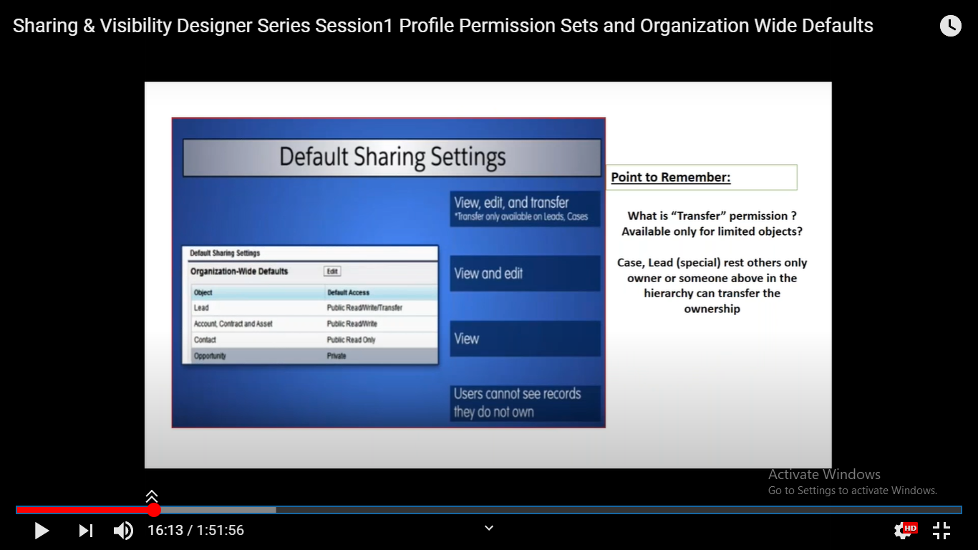

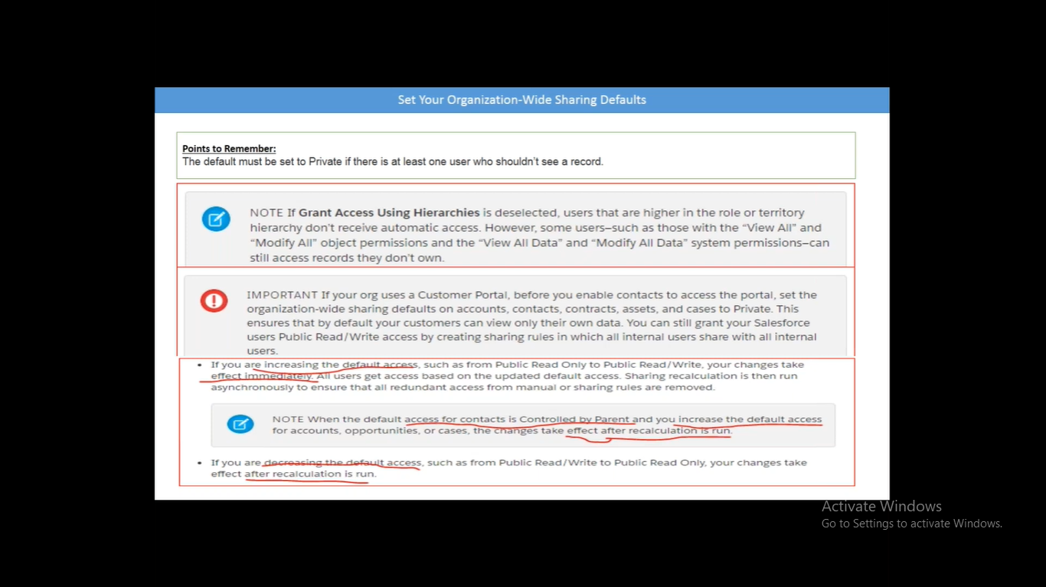

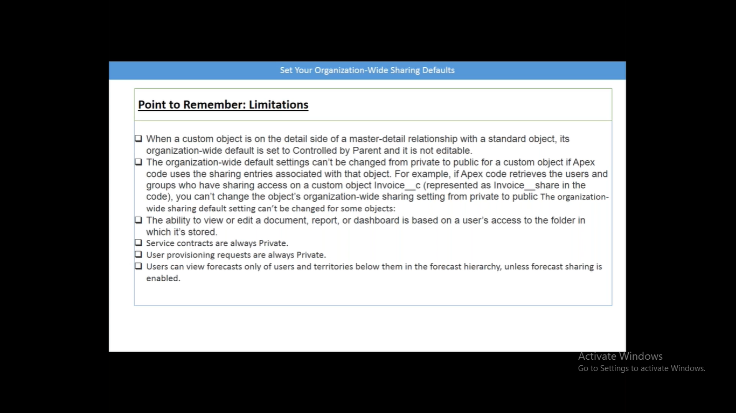

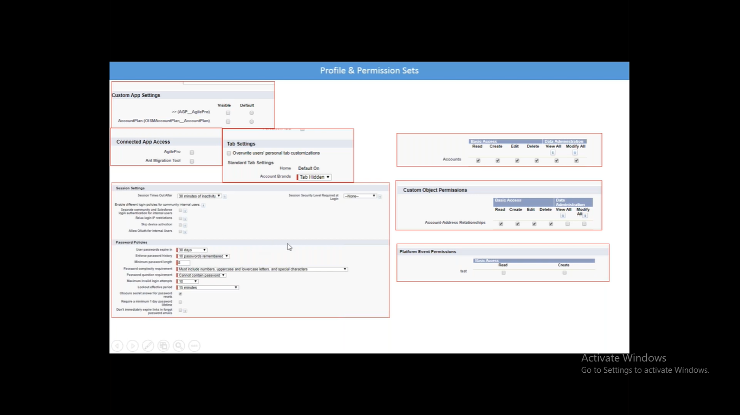

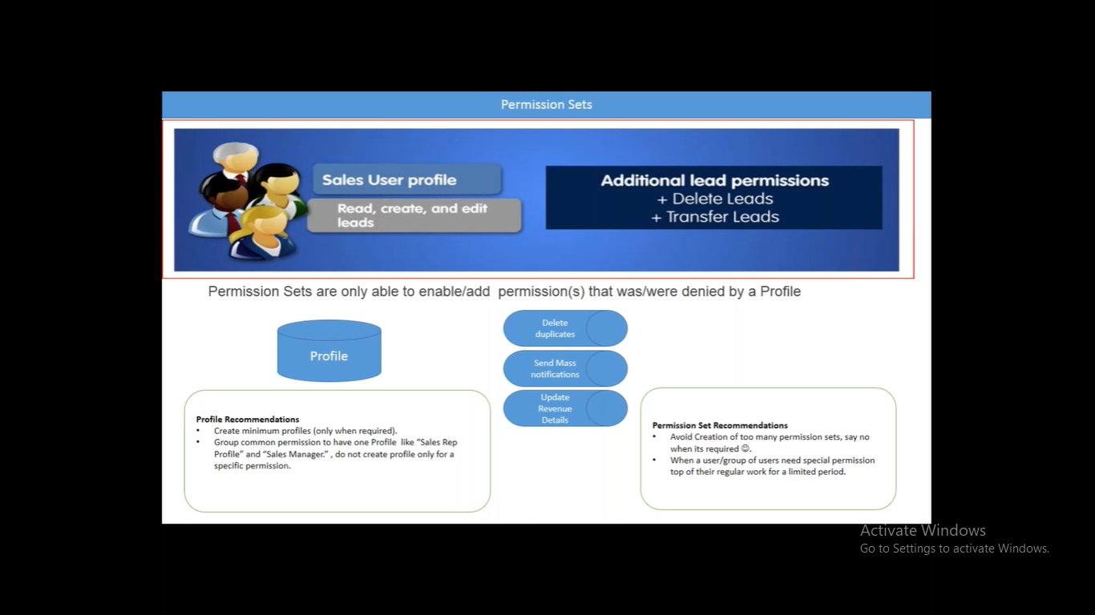

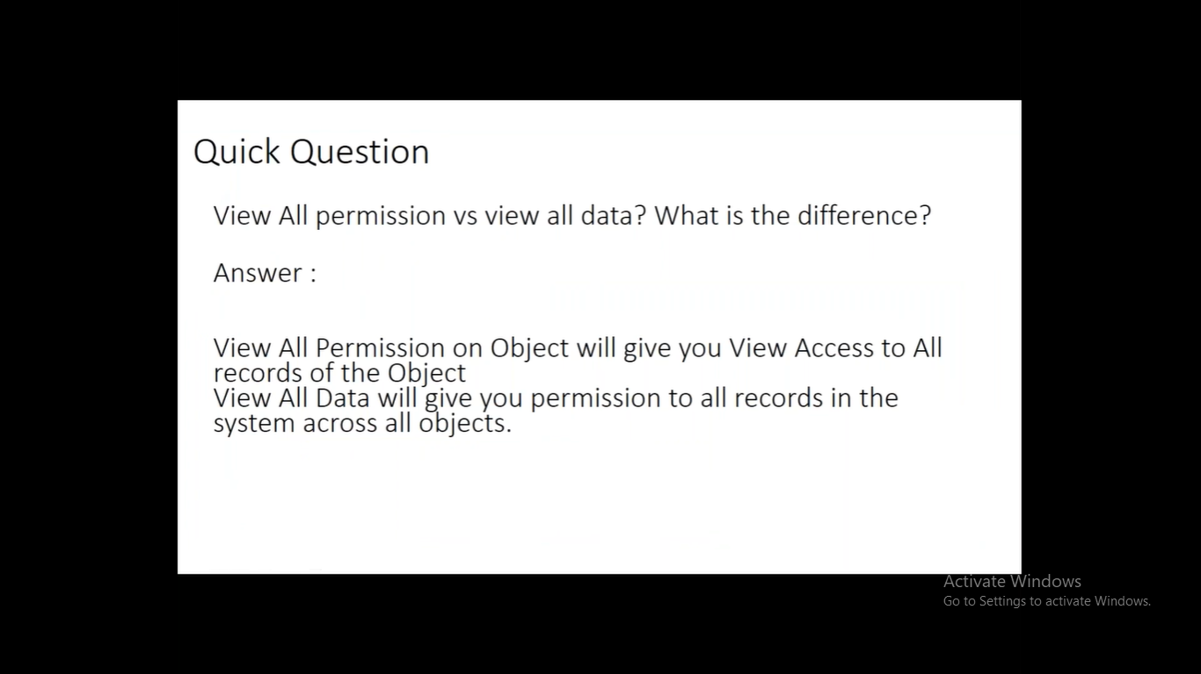

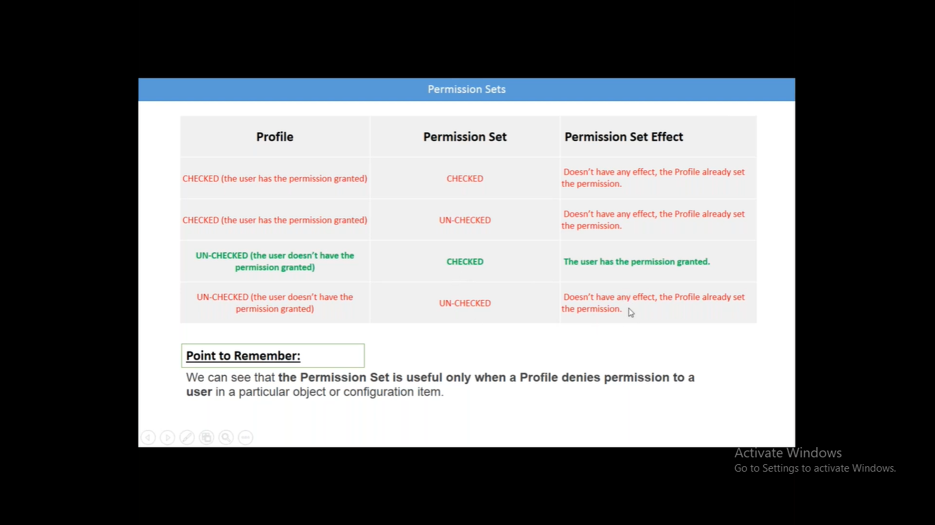

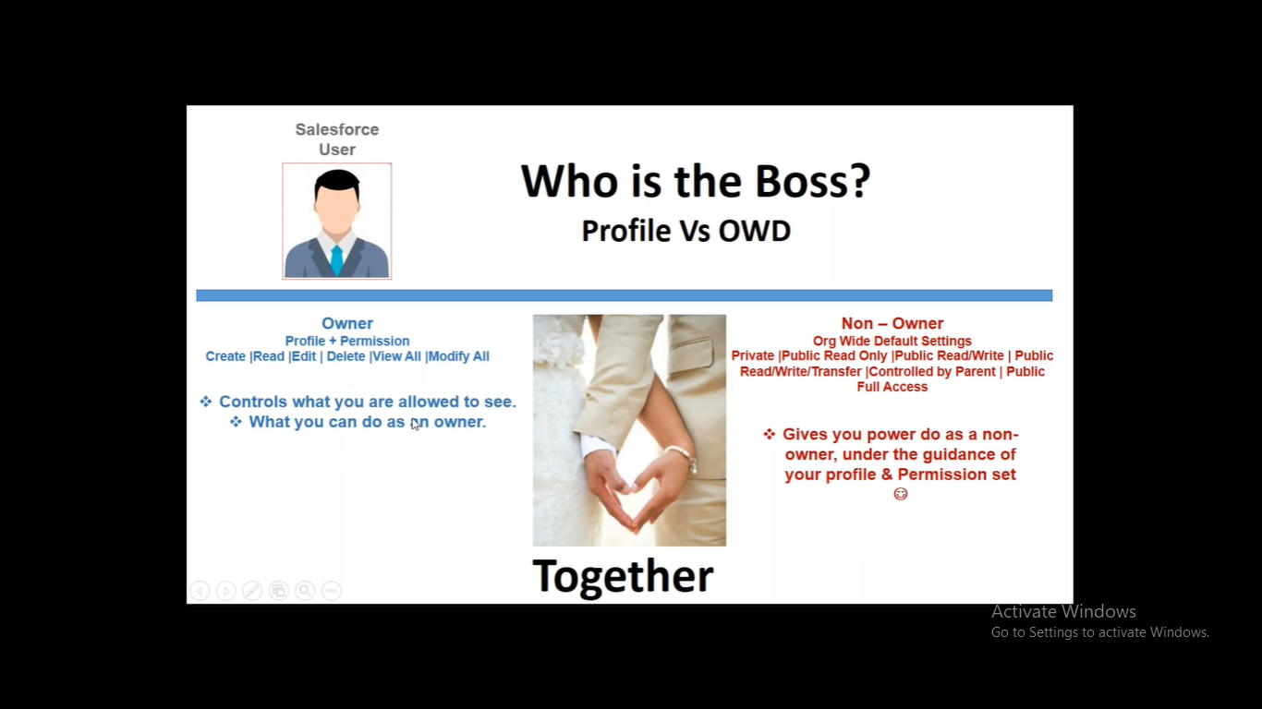

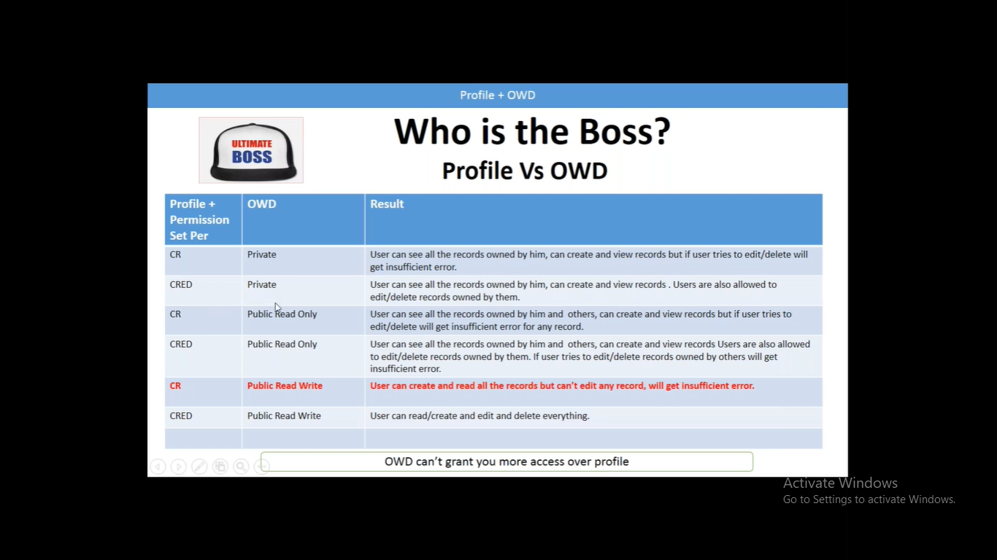

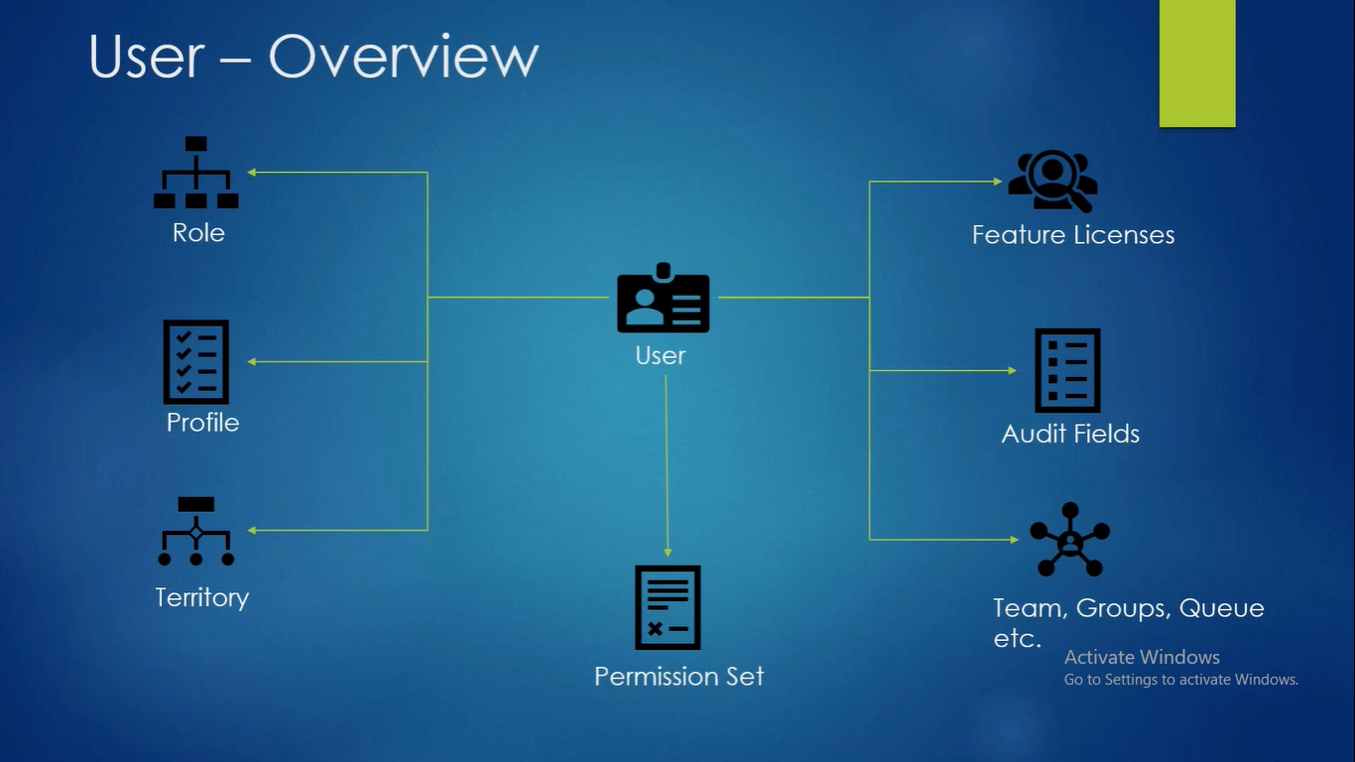

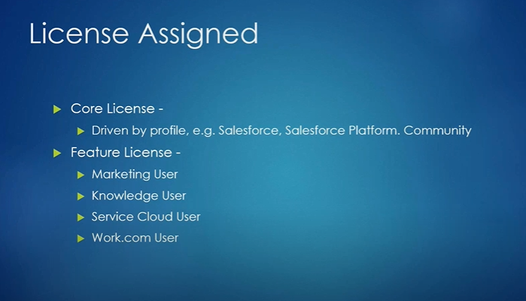

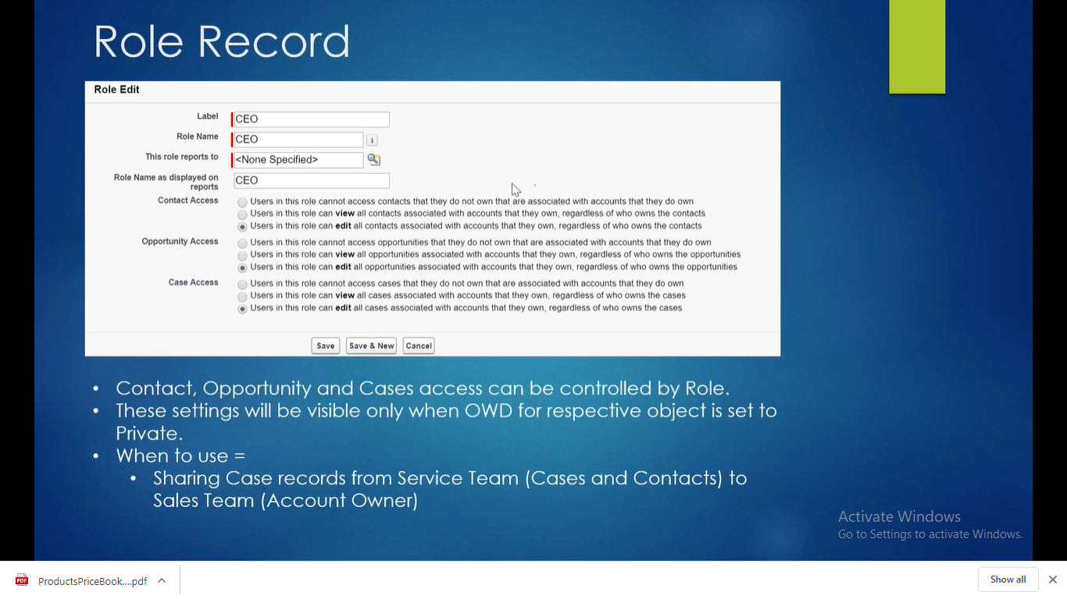

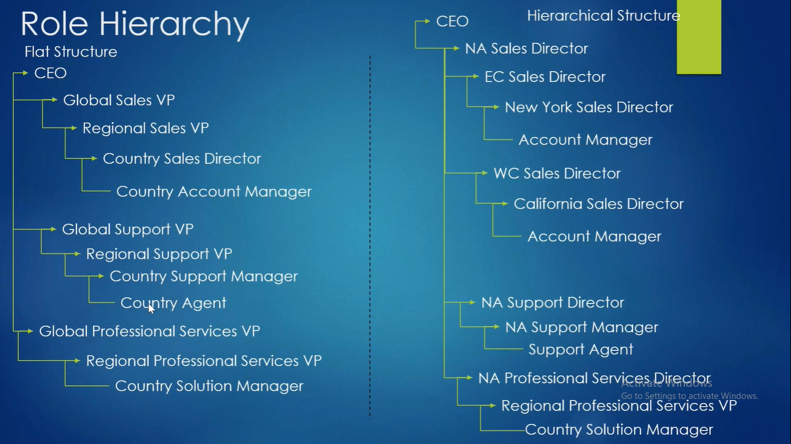

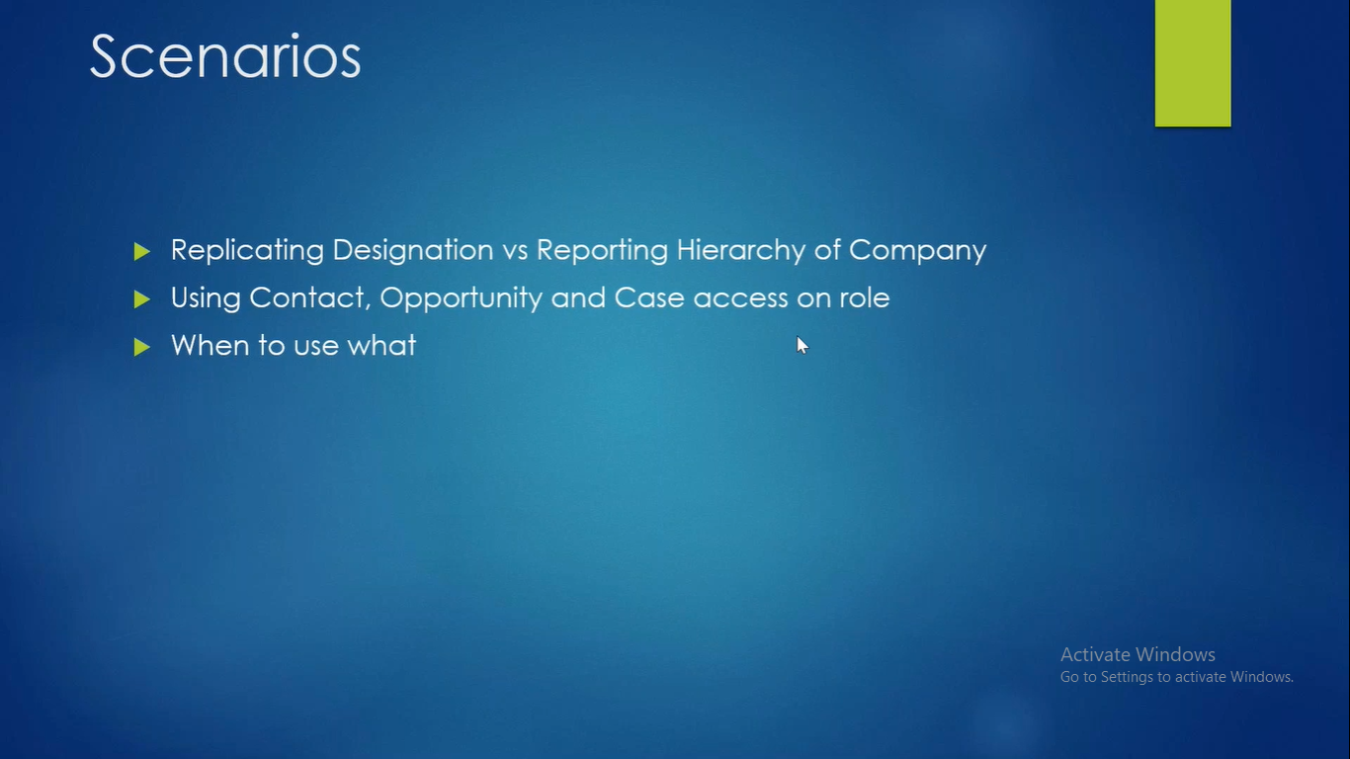

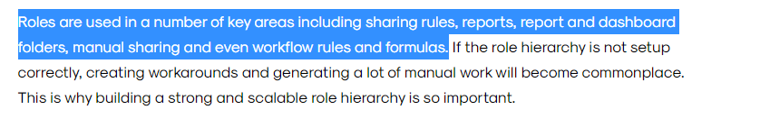

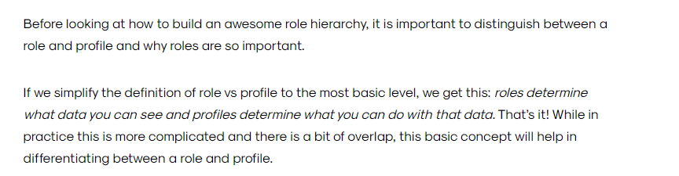

Role hierarchy building basics: <https://adminhero.com/2014/05/26/how-to-build-a-rock-solid-role-hierarchy/>  
<https://torrentconsulting.com/blog/2-reasons-why-salesforce-role-hierarchies-are-so-important/>

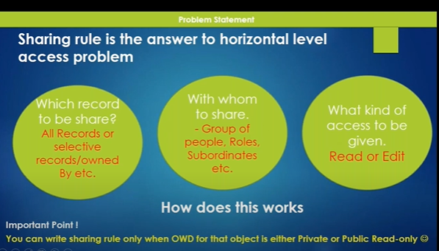

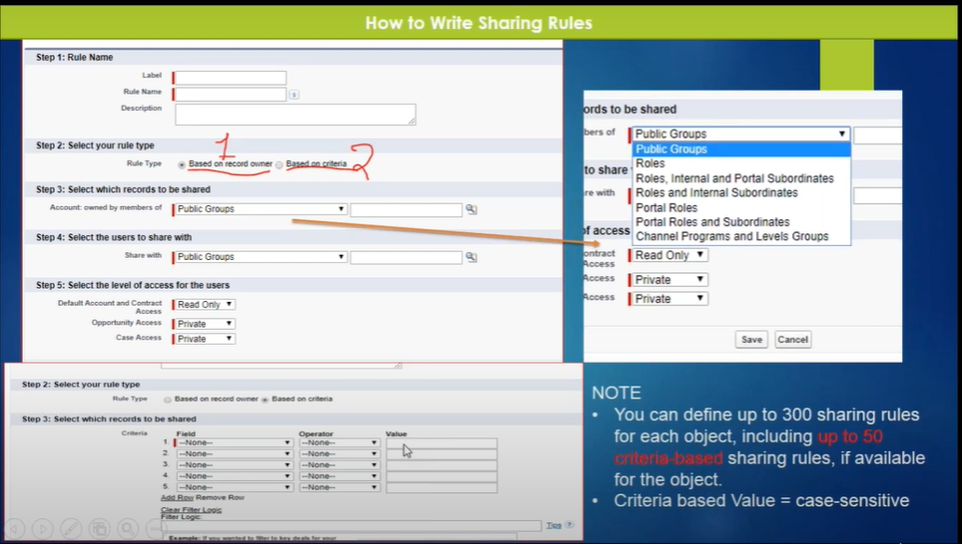

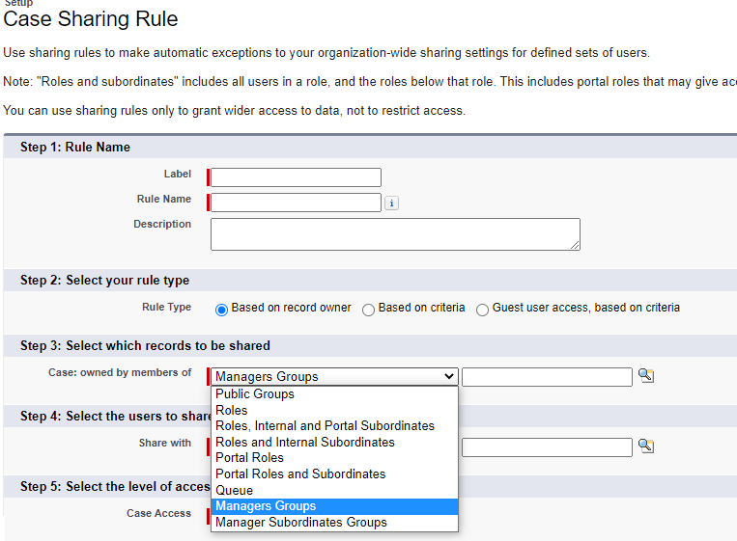

Manager group & manager Subordinates Groups use cases and limitations: <https://focusonforce.com/configuration/salesforce-manager-group-sharing/>

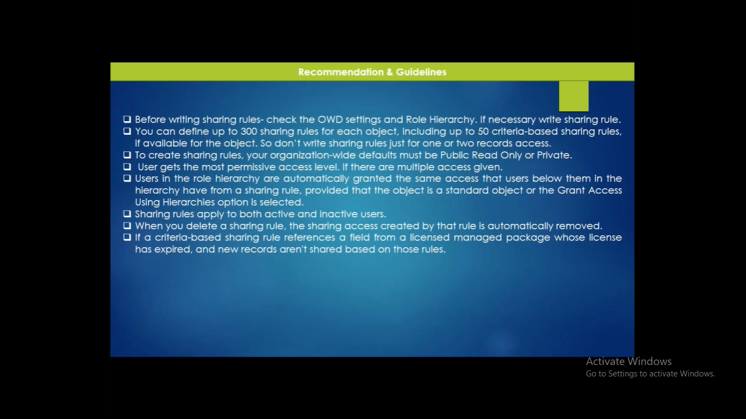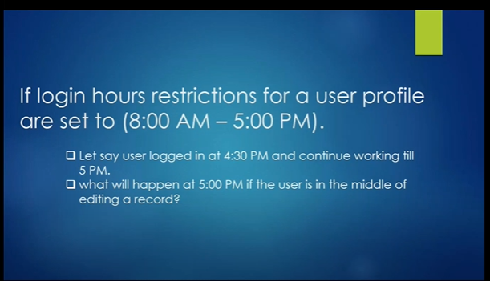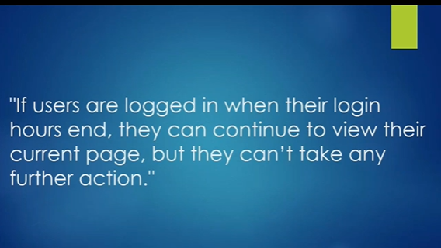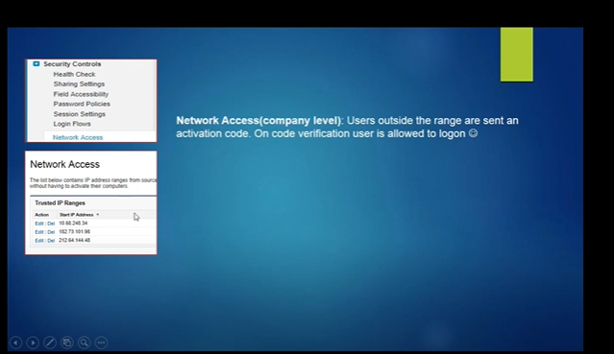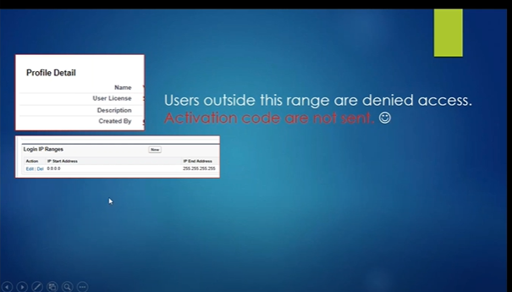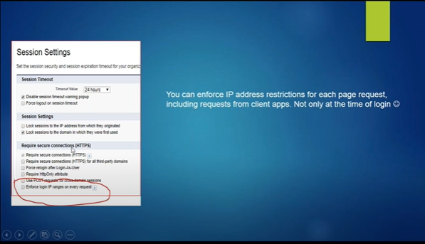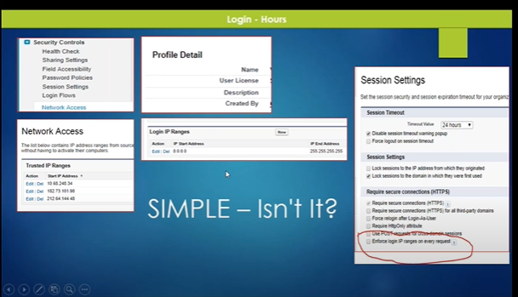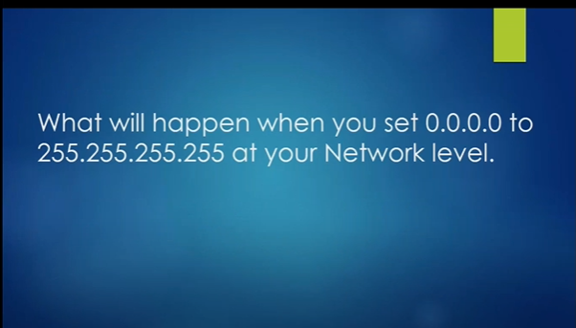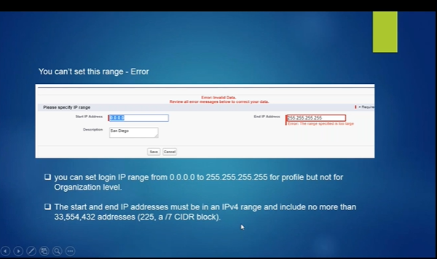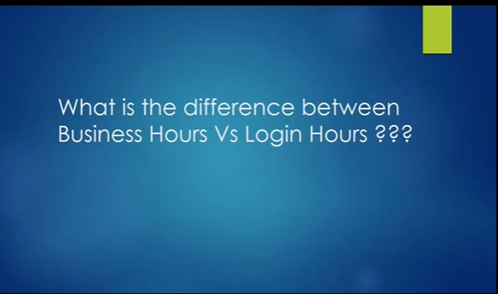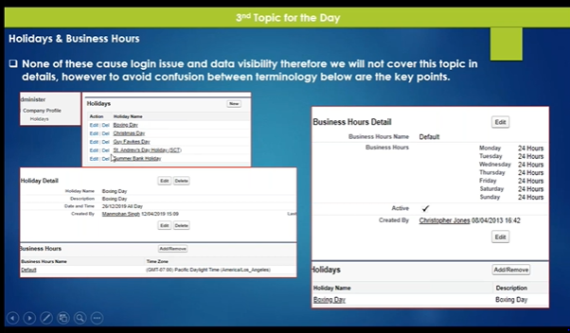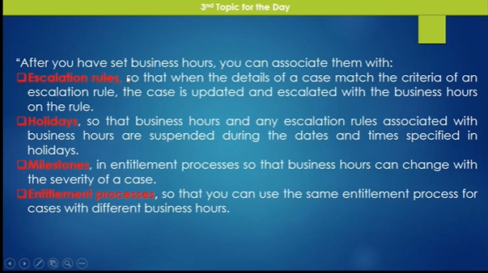

External objects relationship

<https://sfdcbook.blogspot.com/2020/05/external-objects-relationships.html>

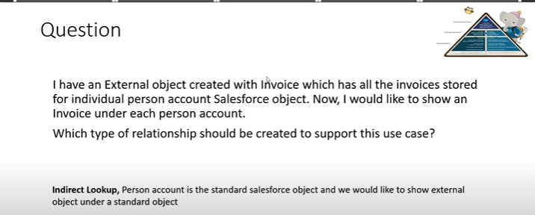

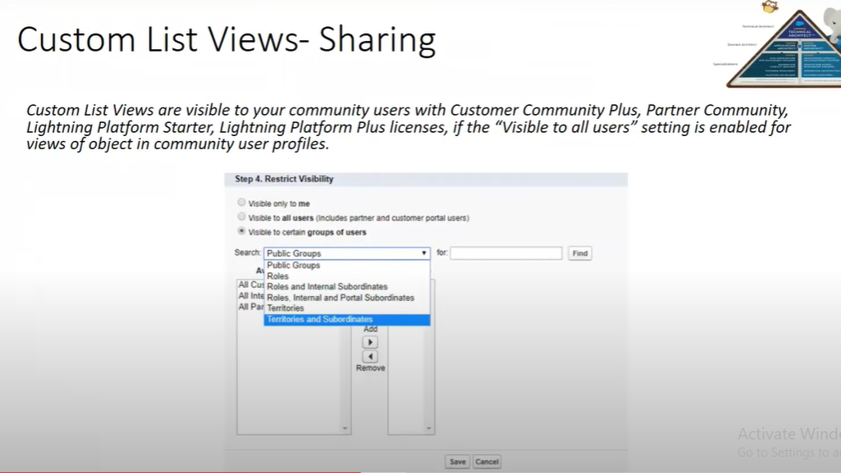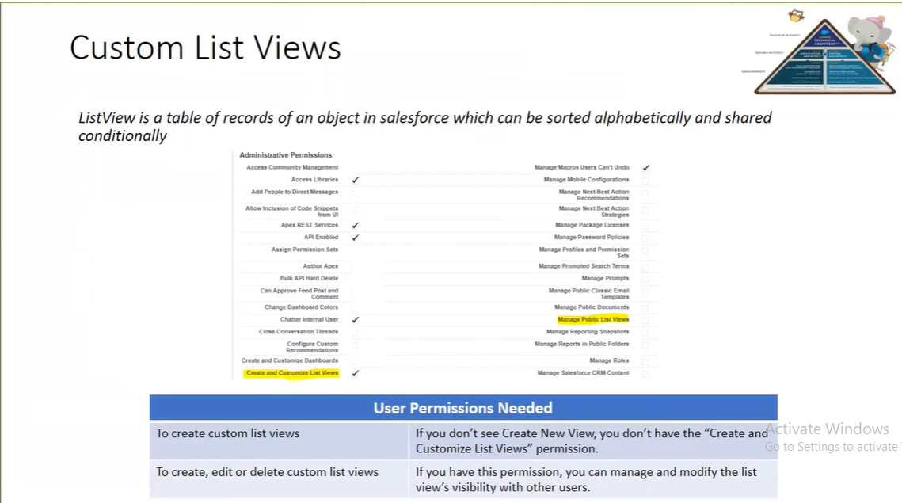



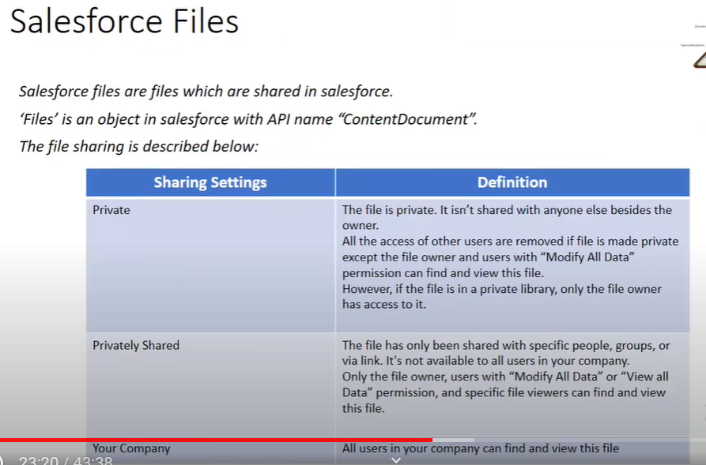

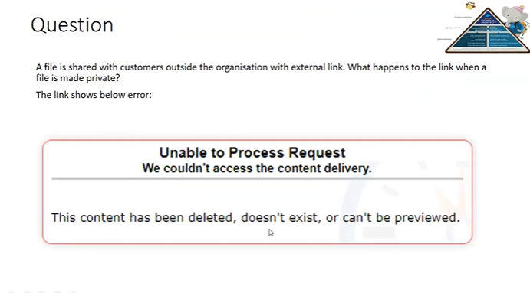

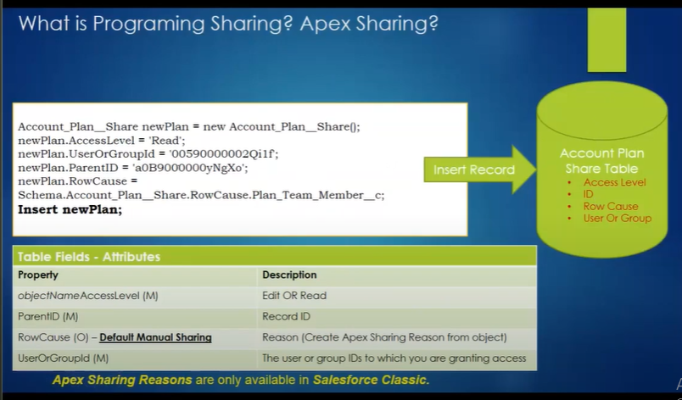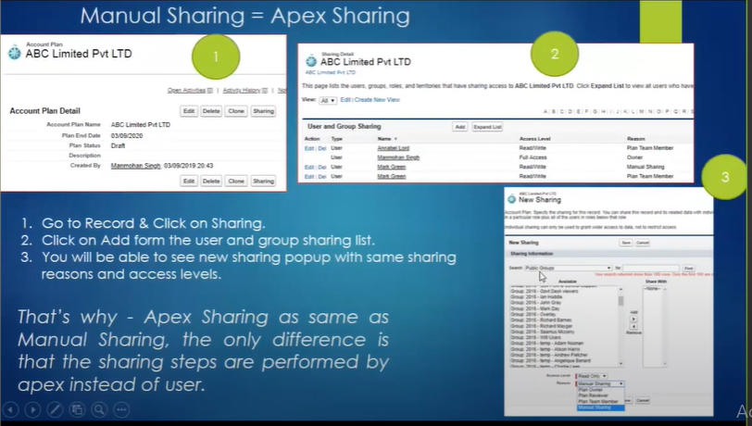

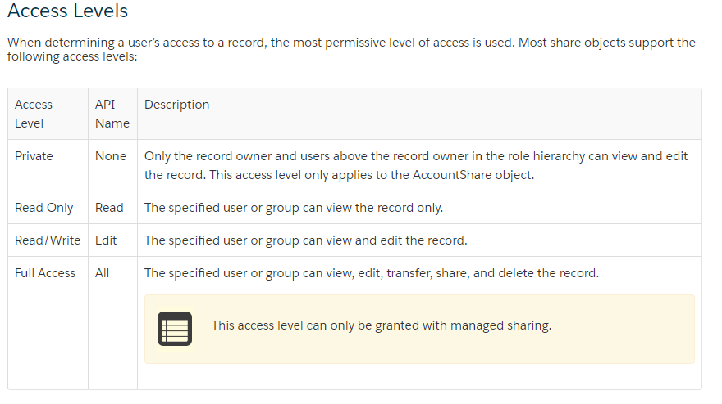

Row cause is only available on Custom objects not for Standard Objects, there is an Idea created for the same. <https://trailblazer.salesforce.com/ideaView?id=08730000000BqPU>

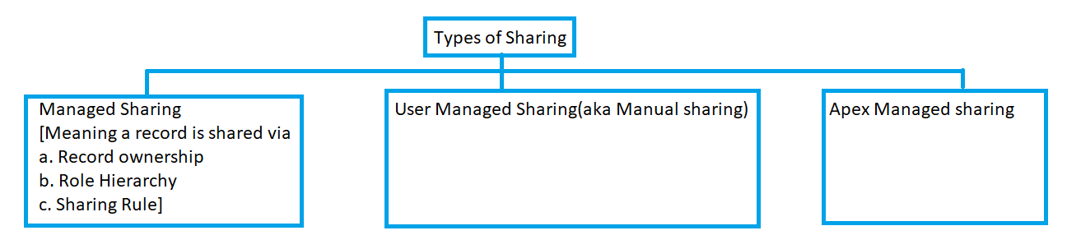

Row cause values will change based on Sharing type.

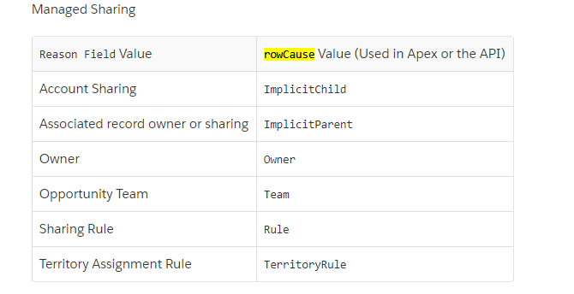

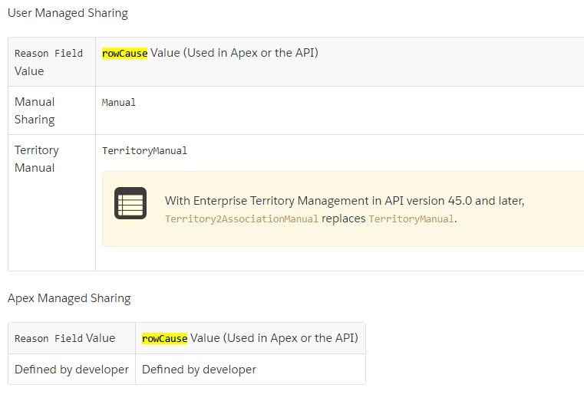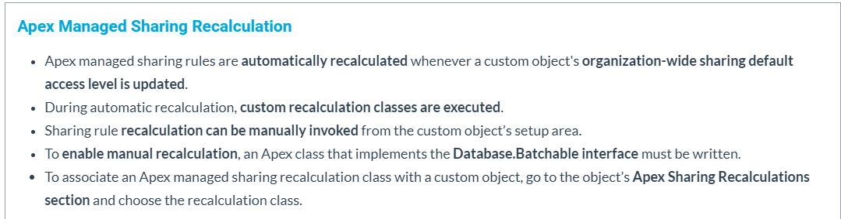

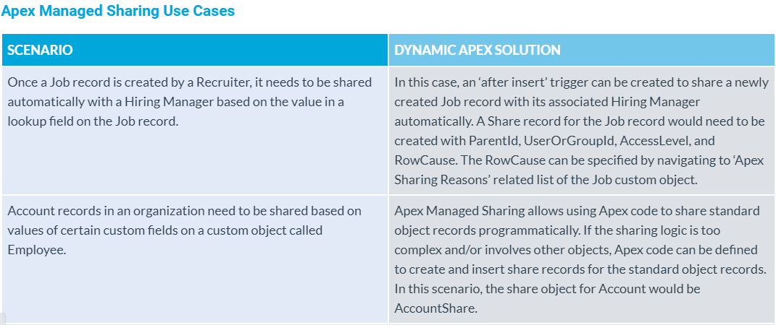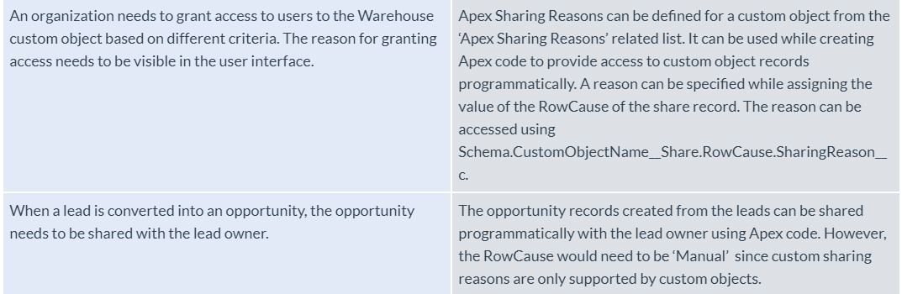

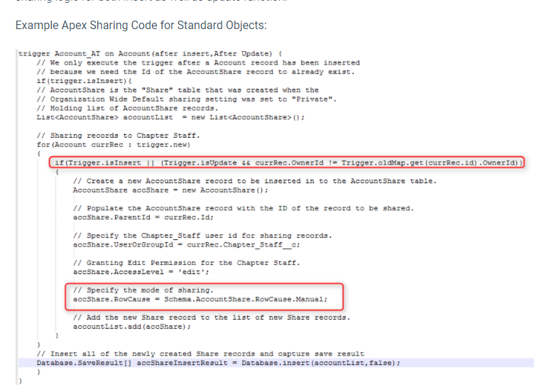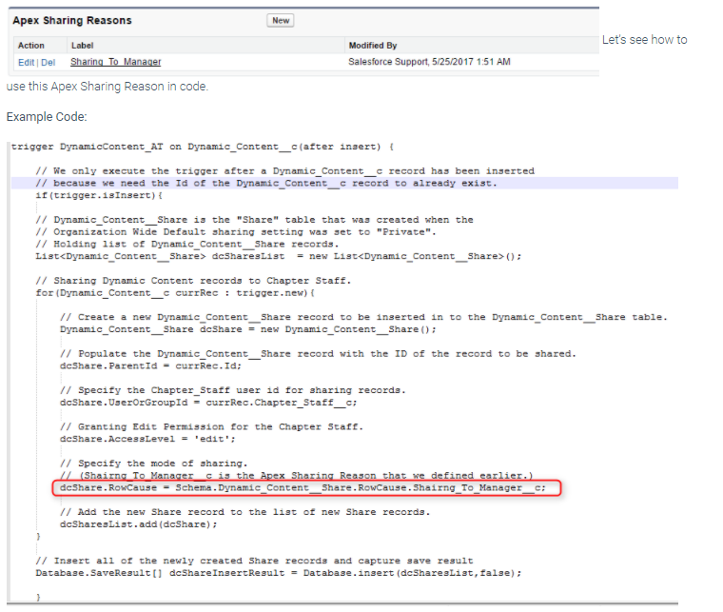

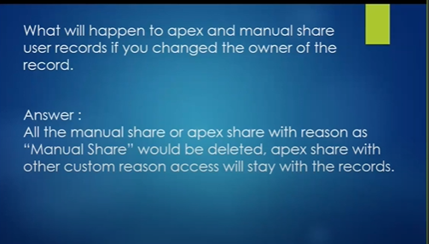

<https://www.jitendrazaa.com/blog/salesforce/system-mode-or-god-mode-in-apex-gotchas/>

**User Mode:** [As per this Salesforce post](https://developer.salesforce.com/docs/atlas.en-us.pages.meta/pages/pages_intro_what_is_it.htm), all Profile level permissions, sharing rules and Field level security are enforced in Apex if it runs in User mode. Standard Controller and Anonymous Apex run in User mode.

**System Mode:** [Same post](https://developer.salesforce.com/docs/atlas.en-us.pages.meta/pages/pages_intro_what_is_it.htm) conforms that custom controller, trigger, Apex class, controller extension works in System mode. Means even though user does not have necessary profile level permission, record level permission or field level permission, but still they can perform any operation on it.

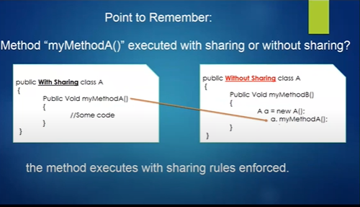

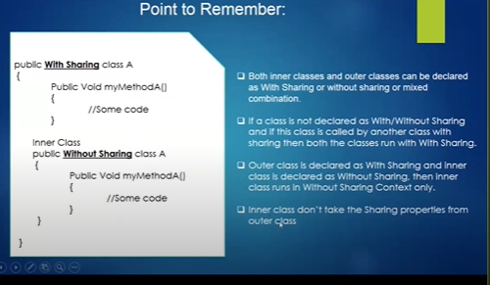

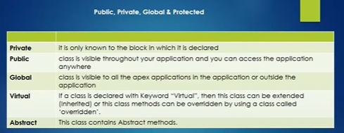

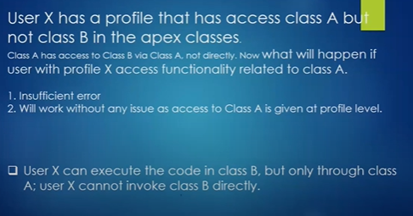

User mode – system mode

<http://santanuboral.blogspot.com/search?q=user+mode>

Inherited sharing:

<https://sfdcbook.blogspot.com/2018/12/interview-questions-part-5.html>